**Institute of Technology Tralee**

**Computing Department**

**Object Oriented Programming 1**

**__________________________________________________**

**Tutorial 2 – Looping with decision-making**

**(a)** Write a Java program that reads in a sequence of user-supplied positive whole numbers (terminated by entering -1) using a **while** loop and, when the loop finishes, displays a list of all the numbers which were

* Greater than 20 and less than 100
* Multiples of 3 i.e. exactly divisible by 3
* Factors of 88 i.e. could divide evenly into 88

The average of the numbers entered to 2 decimal places should also be found along with the percentage of numbers entered that exceeded 1000, to the nearest whole number.

Your program would run as follows:

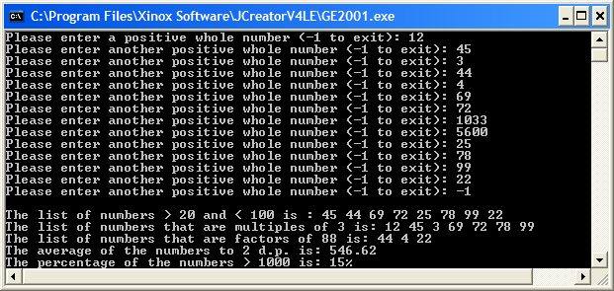

**(b)** Write a Java program that reads the type of exactly 10 animals using a **for** loop. When the loop finishes, the program should display a list of all the animals which

* Began with the letter ‘t’
* Ended with the letter ‘n’(hint: need to use the **length**() method here)
* Contained the letter ‘i’ (hint: need another **for** loop for this part)
* Contained more than 8 characters
* Contained between 6 and 12 characters inclusive

Your program would run as follows:

